[www.birthdayclicks.in](http://www.birthdayclicks.in) Welcomes you!!! ☺

[www.birthdaylcicks.in](http://www.birthdaylcicks.in), a social networking website providing the facility of reminding you the birthday of your special ones.We will notify you about your friend’s birthday before a week,on the day and many more through SMS.

Website provides following functionalities:

**1)HOME PAGE**:

Homepage of website showing you the agenda of website.

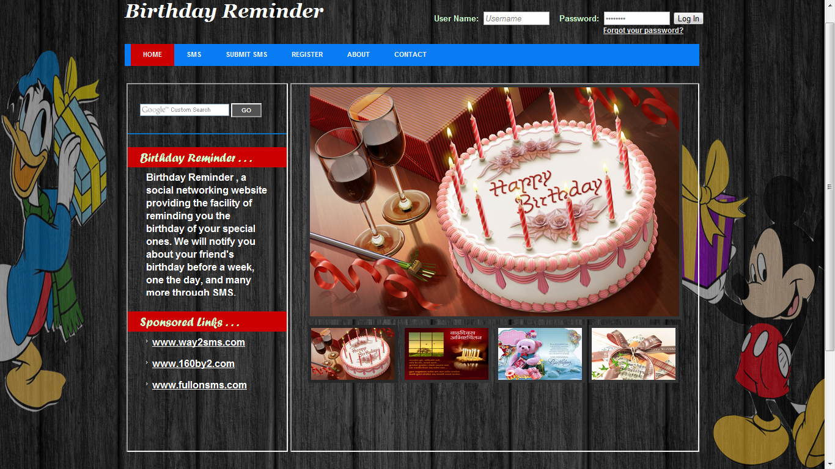

Click here

**2)SMS:**

Here you can see the SMS uploaded by visitors or users,SMS are in catagories such as Birthday,Friendship,Anniversary.

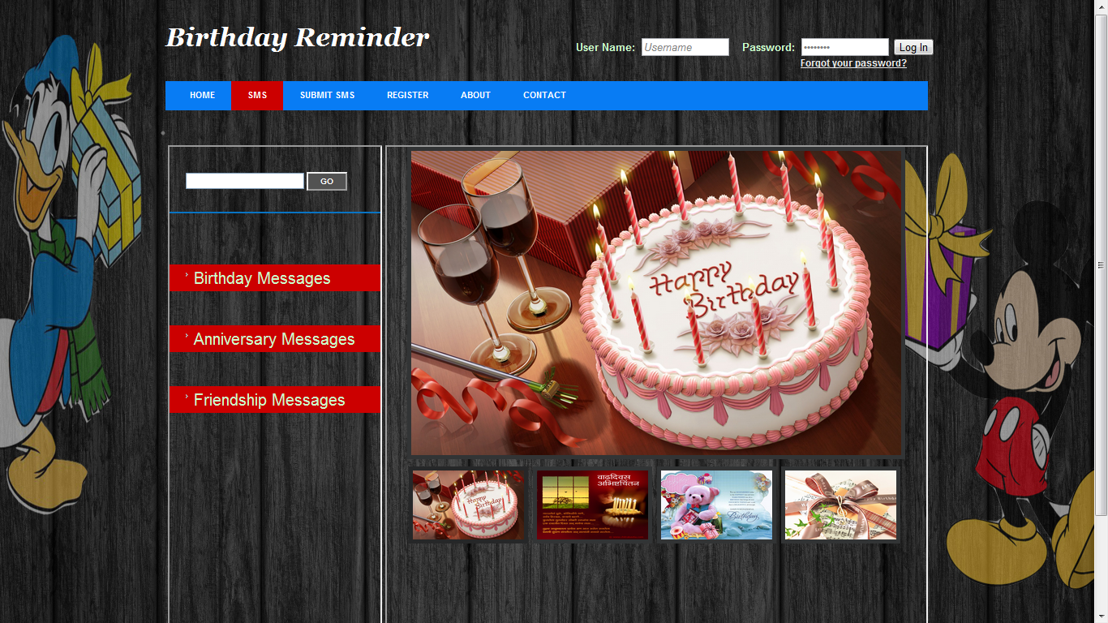

Click here

**SMS Catagories**

**3)SUBMIT SMS:**

This allows you to share your messages on website which can be accessible to visitors.

Here you to submit your message along with your name and the category of message.

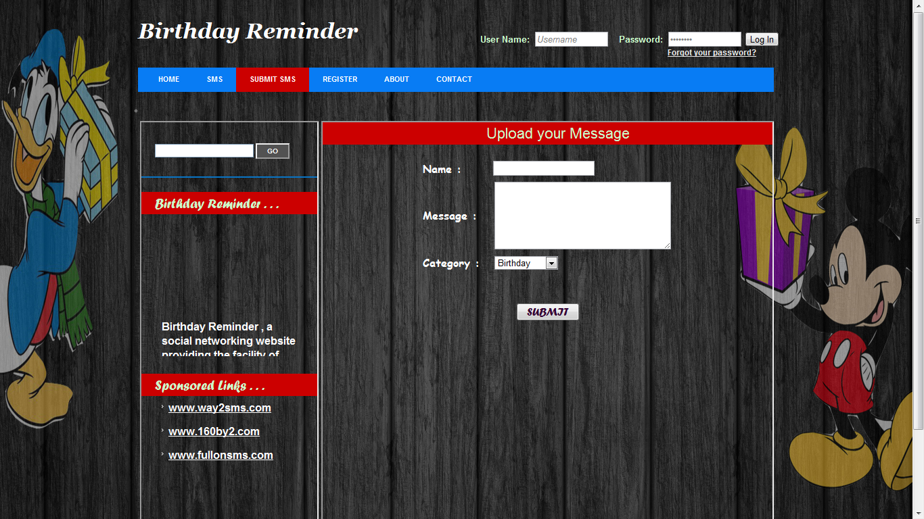

Click here

**4)REGISTER:**

To make use of this site more effectively ,it is necessary that you must be user of it, to become user you have to make registration over here.

For that you must fill correct information. And finally click on SUBMIT button.

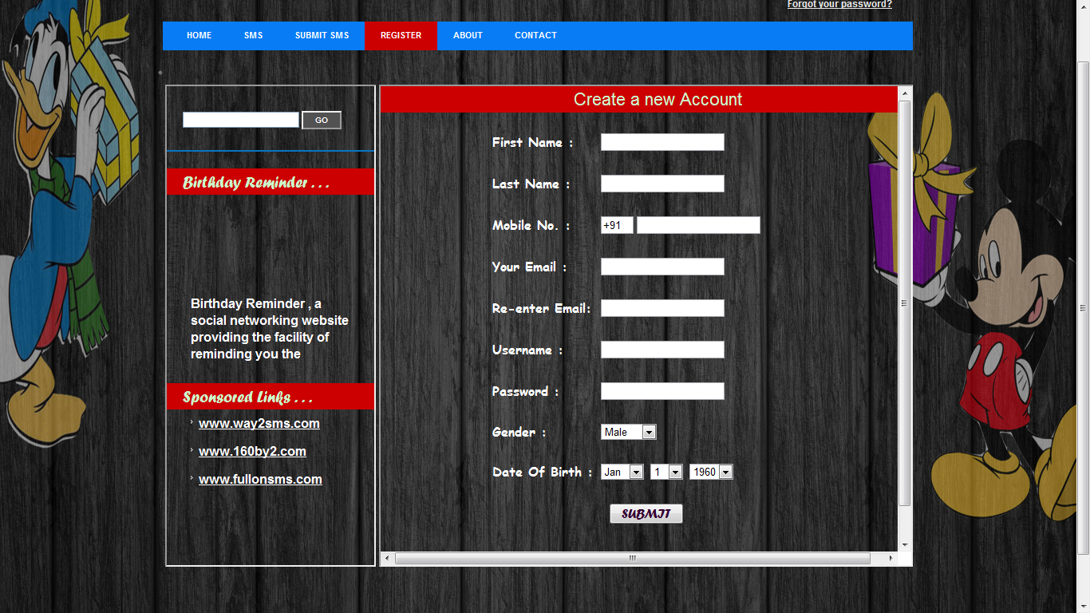

Click here

**5)ABOUT:**

This page shows you information about developers.

Developers:

1]Mayur J. Jadhav

2]Vishal S. Dawange

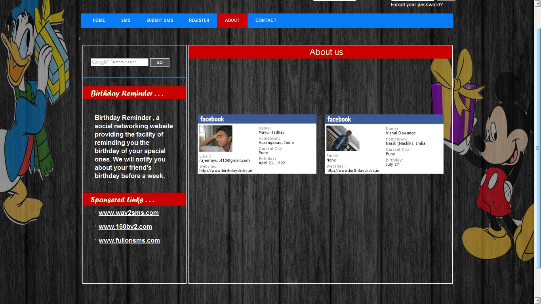

Click here

**6)CONTACT**:

Submit your suggestions, problems regarding the website, here.

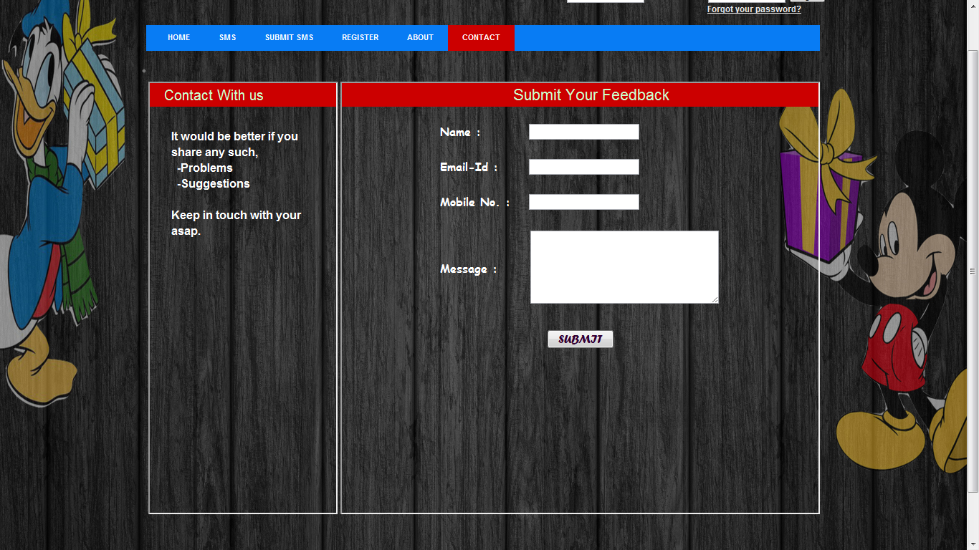

Click here

**7) LOG IN to website:**

After logging in to your account you will get 3 options

-My Wall

-Add friend

-Groups

**MY WALL:**  It will show you upcoming birthdays from your friends list.

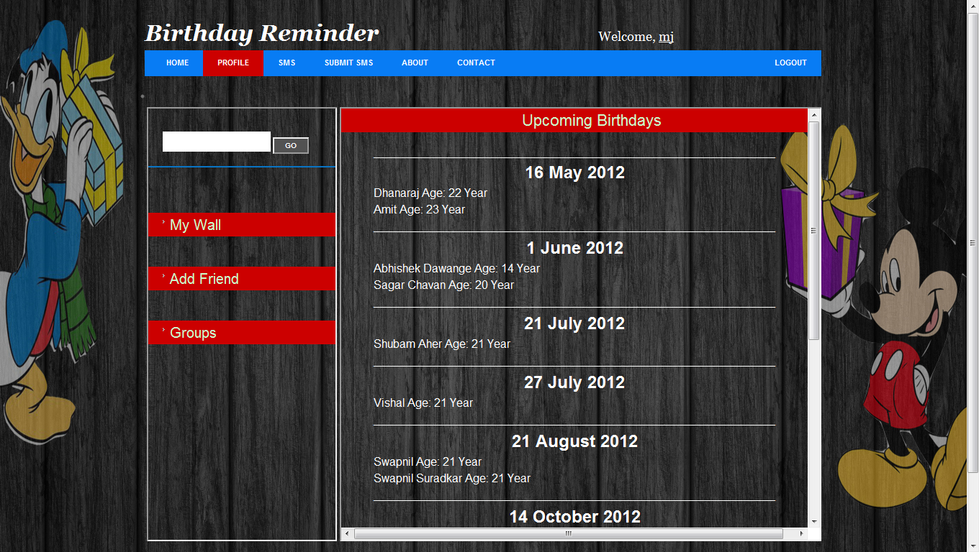

Click here

**ADD FRIEND:**

Here you can add friends to whom you want to wish on his/her birthday.

For that you have to add correct information related your friend.

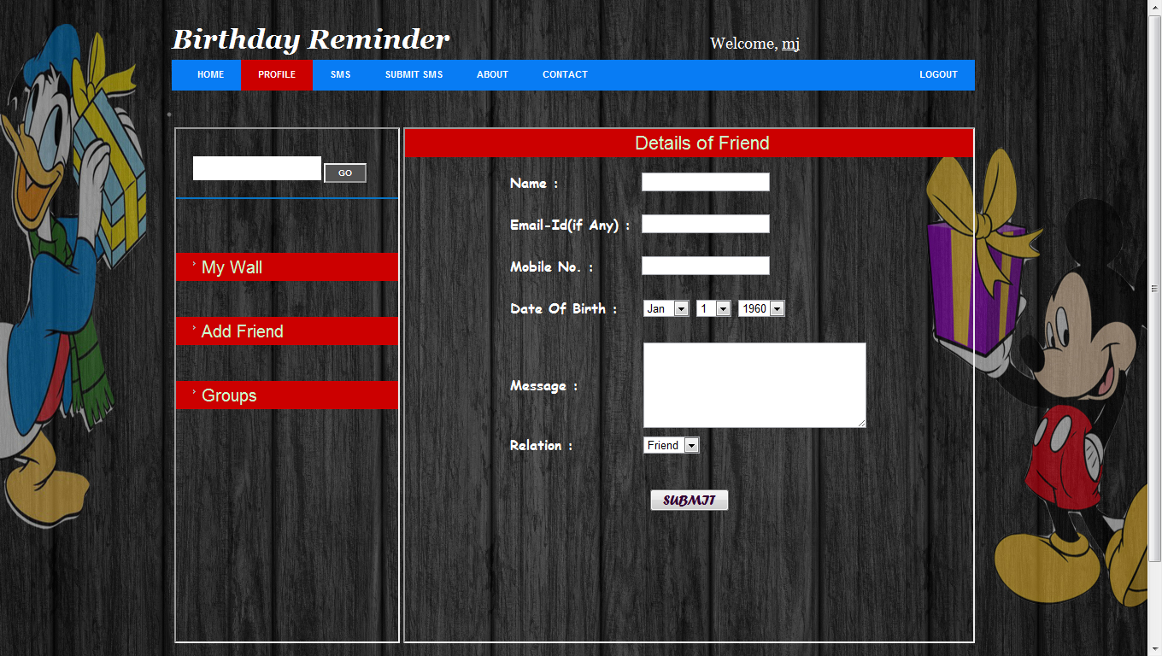

**GROUPS:**

It will show your friends from the groups:1)Friend 2)Family.

At the time of add friend you have select the group of that person you are adding.

